

To: Cabinet

Date: 10 December 2025

Item No:

Report of: Group Finance Director

Title of Report: Medium Term Financial Strategy 2027-28 to 2029-30 and
2026-27 Budget for Consultation.

Summary and Recommendations

Purpose of report: To propose a Medium-Term Financial Strategy and the 2026/27 Budget for consultation

Key decision Yes

Executive lead member: Councillor Ed Turner

Policy Framework: The Council’s Corporate Strategy and Council’s Budget

Recommendation(s): That Cabinet resolves to:

1) Approve the 2026-27 General Fund and Housing Revenue Account budgets for consultation and the General Fund and Housing Revenue Account Medium Term Financial Strategy as set out in Appendices 1-10, noting:
a) The Council’s General Fund Budget Requirement of £30.945 million for 2026/27 and an increase in the Band D Council Tax of 2.99% or £10.67 per annum representing a Band D Council Tax of £367.38 per annum assuming it is confirmed that the authority is able to do so.

b) The Housing Revenue Account budget for 2026/27 of £68.2 million and an increase of 4.8% .(average of £8.47 per week) in social dwelling rents from 1 April 2026 (see paragraphs 90-92) giving a revised weekly average social rent of £143.40 as set out in Appendix 5.

c) The increase in shared ownership rental in accordance with the lease as shown in paragraph 93-94

d) The General Fund and Housing Revenue Account Capital Programme as shown in Appendix 6.

2) Agree the fees and charges shown in Appendix 7

3) Delegate to the Section 151 Officer in consultation with the Board Member for
Finance and Assets the decision to determine whether it is financially advantageous for the Council to enter into a Business Rates Distribution Agreement as referred to in paragraphs 29-30 of the report.

Appendices to the report
Appendix 1 Summary of General Fund Budget by Service 2026-27 to 2029-30
Appendix 2 General Fund Revenue Budget by Service 2026-27 to 2029-30
Appendix 3 Detailed General Fund and HRA Service Budgets 2026-27 to 2029-30
Appendix 4 Housing Revenue Account Budget 2026-27 to 2029-30
Appendix 5 Council House Rents By Estate
Appendix 6 General Fund and HRA Capital Programme 2026-27 to 2029-30
Appendix 7 Fees and charges
Appendix 8 Risk Register
Appendix 9 Equalities Impact Assessment
Appendix 10 – Properties purchased from OXPlace – EXEMPT FROM PUBLICATION

Comment from the Portfolio holder

It is both a challenging and uncertain time for local authorities, including Oxford City Council. We face substantial pressures on services, in line with previous budgets but with Oxford’s housing crisis, in particular, adding huge pressure. The government has announced it will reorganise local government, and there are three competing proposals for Oxfordshire. In addition, long-delayed reforms to local government finance are to be introduced from next year, and we await details of how these will affect Oxford City Council.
In proposing this consultation budget, we recognise these circumstances, while nonetheless trying to improve services, and continuing to prioritise areas about which we care greatly, such as building new, genuinely affordable housing, narrowing the gap between rich and poor and supporting community organisations. Amongst the important features of this budget are:
- Funding for 1,692 new council homes delivered directly or through our wholly owned housing company OxPlace
- Continued support for the “Oxford Model”, which is projected to deliver over £12 million in dividends from wholly-owned companies
- Backing for the Oxford Living Wage for staff and contractors
- Improvement in services, including longer opening of Hinksey Pool, recruitment of new community response officers to improve safety and tackle anti-social behaviour, and reintroduction of a creche at Blackbird Leys Pool and funding for cricket nets on Blackbird Leys.
- Provision of £1 million to renew the roof of Oxford Ice Rink.
- Mobilisation of government funding for Cowley Branch Line and use of funds from development to ensure the process is properly managed.
- Continuation of full council tax reduction for those on the lowest incomes.
There are other areas in which we would like to invest, but we will await publication of the funding settlement and address those once we know our position for next year.
We face a major challenge in the provision of temporary accommodation for homeless households. As a result, we are setting aside £32 million to help purchase 260 properties which can help those who become homeless, and reduce the need to use costly, unsuitable hotels accommodation.
As ever, producing a budget involves difficult choices. Under our proposals, council tax and some other charges will go up by a modest amount, so that we do not have to lose some of our most important amenities, such as community and leisure centres, as is happening in other parts of the country. We also propose selling some council property, and invite views on whether we should sell the Lord Mayor’s number plate, so that this money can be reinvested in services. We will welcome feedback from members of the public as part of our budget consultation.
INTRODUCTION

- This report sets out the Council’s Medium Term Financial Strategy (MTFS) and associated spending plans for the four years 2026/27 to 2029/30 and gives interested parties the opportunity to comment and be consulted on the Council’s budget proposals for the financial year (2026/27). The report covers all aspects of the Council’s spend: General Fund revenue expenditure funded by the council taxpayer, government grant and other sources of income, Housing Revenue Account (HRA) expenditure, funded by council tenants’ rents, and the Council’s Capital Programmes (General Fund and HRA) funded by capital receipts, revenue and borrowing.

- The proposed Medium Term Financial Strategy:

- Is financially balanced over the four-year period with the use of a net £8 million of reserves.
- Assumes a council tax increase of 2.99% for 2026-27 and thereafter.
- Assumes dividends from our wholly owned companies over the four-year period of around £12.6 million.
- Assumes an increase in council house rents of 4.8% in 2026-27 to an average of £143.40 per week.
- Assumes 1,200 new build dwellings by the council’s wholly owned Housing development company OXPlace of dwellings over the life of the 8-year development programme, in addition to 100 acquisitions by the HRA.
- Facilitates capital investment of £725 million over the next four-year period.

- For ease of reading, the report is split into four sections:

Section A Economic context, our priorities and budget setting strategy
Section B General Fund Revenue Budget
Section C Housing Revenue Account (HRA) Budget
Section D Capital Programme

Section A - Background and Context

Background

- This report sets out the Council’s financial plans for the period 2026/27 to 2029/30. The plans make assumptions about income from Government grants, Council Tax and rents. The plans underpin service provision and the Council’s vision of “Building a World Class City for Everyone”.
- The English Devolution White Paper (published on 16th December 2024) set out the government’s vision for simpler local government structures. On the 5th February 2025 the Government issued a statutory invitation to all councils in two tier areas and small neighbouring unitary authorities to develop proposals for unitary local government. These proposals bring together lower and upper tier local government services into new unitary councils to deliver Local Government Reorganisation.
- The timeline Government have set out for the reorganisation is
  - Submission of unitary proposals – 28th November 2025
  - Consultation on options – Spring 2026
  - Decision on proposals by Government – July 2026
  - Elections to Shadow authorities May 2027
  - 1-4-2028 – vesting day of new councils and dissolving of predecessor councils
- The Council has no way of knowing the future direction of the authority until Summer 2026. As such Oxford City Council has been assumed to be a going concern for the foreseeable future and no financial implications of establishing or operating in a new unitary set up have been included within the MTFP. However, in order to get a ‘head start; on preparations for unitary status an amount of £2million has been included in the MTFP in 2026-27 to cover the costs of project management and consultancy.
- The Council operates the ‘Oxford Model’ which seeks to support and maintain services from income streams driven from fees and charges, income from our assets and financial returns from our wholly owned companies. A breakdown of gross income of around £82 million from various sources is shown graphically below.

Picture 1 : General Fund Revenue Income 2025-26

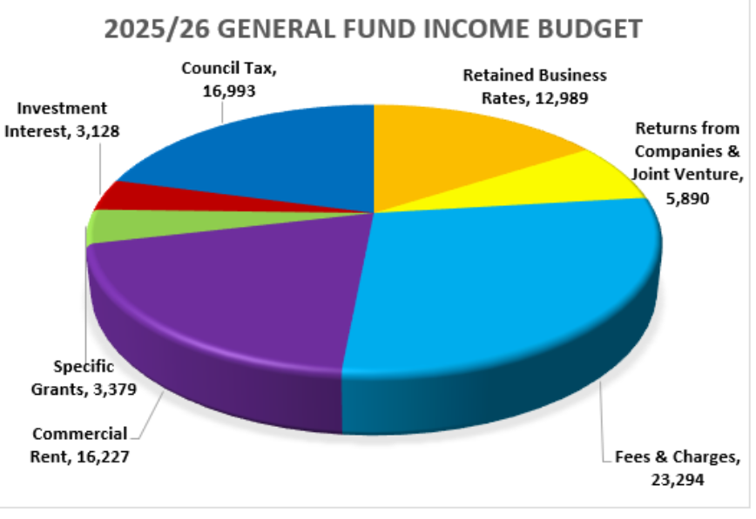

9 Over half of our financial resources are derived from sources generated by the Council, with 7% being delivered by the Council’s wholly owned companies OXPlace and ODS. This level of income maximisation requires a commensurate level of staff, providing technical knowledge and professionalism without which the council would need to make unprecedented cuts in its services.

Inflation
- Consumer Price Index (CPI) inflation has remained unchanged for September from the previous two months at 3.8% which is below analysts’ expectation of 4%. The Bank of England expects September’s figure to be the peak and for inflation to slow down through the rest of 2025 and 2026. There is still an expectation that inflation reduces to the Bank of England’s 2% target from 2026 onwards as shown in the chart below. Budgets for most supplies and services the council purchases are cash limited and therefore any increase in inflation represents real terms cut for service managers.

Picture 2: Inflation Forecasts -Office for budget Responsibility

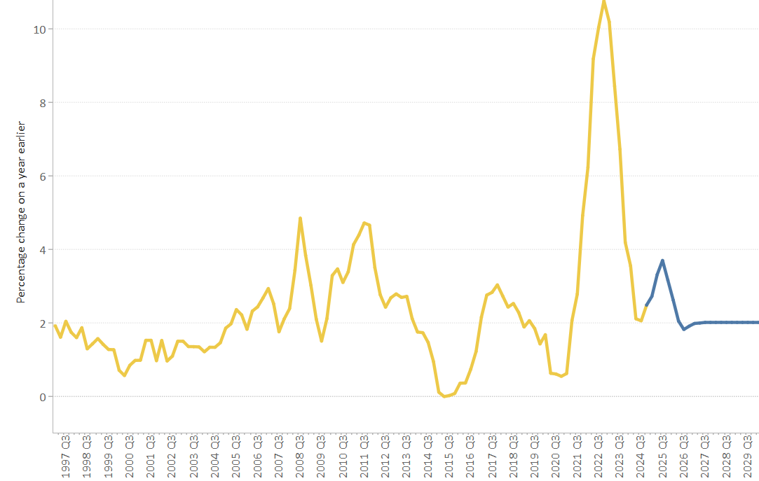

Interest Rate Forecasts

- On the 6th November 2025 the Bank of England maintained base rates at 4.00%, where it has been since the last reduction in August. MUFG Investor Services and Capital Economics, two of the leading advisors on Treasury related matters, have given their view on interest rate forecasts as shown below:

Table 1: Interest rate forecasts from December 2025 to September 2027

- Whilst the hold in base rates has been welcome news the Bank of England Governor warned ‘we’re not out of the woods yet’. Analysts had not expected interest rates to be cut given that prices are rising at nearly twice the banks target rate, but the Bank did say that it expected inflation to return to its key target of 2%.

- The council holds £288 million of external debt all in respect of HRA self-financing taken out in April 2012. The Council capital programme is heavily financed by borrowing although the Council currently uses internal funds, as these are the cheapest form of borrowing. As the Capital Financing Requirement (the underlying need to borrow to fund the capital programme) increases so will the need to undertake external borrowing.

Autumn Budget and Spending Review 2025

- In the period June 2025 to August 2025 the Government ran a number of consultations on
- Fairer Funding 2.0. The consultation sought views on the approach to determining new funding allocations for local authorities with specific reference to a number of areas including:

- Determining local authority funding allocations
- Measuring differences in demand for services and the cost of delivering them
- Measuring differences in local available resources
- New Homes Bonus
- Transitional arrangement and keeping allocations up to date
- The long-term approach to the business rates retention system

There was no mention of the business rates reset which will determine new tariff and top up values to match locally collectable business rates to baselines.

A key element of the consultation included the Government’s intention to the rolling in further grants such as nearly £10 billion of social care funding into the Settlement Funding Assessment (Relative Needs – relative resources = SFA) in effect subjecting them to the Fairer Funding process, whereas currently such grants are in the main allocated to unitaries and County Councils

- Homelessness prevention grant (HPG)- In June 2025 the Government launched a consultation on the funding arrangement for HPG from 2026-27 onwards. HPG is currently allocated to local authorities based on relative homeless demand and cost pressures. The authority’s current HPG grant for 2025-26 is £2.131 million. Under the proposals 45% of this funding will be for temporary accommodation (to be combined with RSG) and 55% on prevention and relief to support local authorities to shift funding towards prevention. There will be protection for 1-5 years which will only allow allocations to go down by 2-20% over the 5 year period.

- Rough sleeping prevention an recovery grant. The original grant allocation for the authority for 2025-26 was £2.1 million as part of total allocation of £185 million. In October 2025 the government announced a further allocation of £69 million of which Oxford’s share was £0.970 million.

- Business rates retention –

  - The Government confirmed their intention to undertake a reset of the Business Rates Baselines with effect from 1-4-2026.
  - All growth above baselines to date will be reset and growth that comes on stream after reset will be retained for the duration of the reset i.e. 3 years.
  - Alongside the 2026 reset there will be a business rates revaluation reflecting changes in the property market resulting in decreases or increases in ratepayer bills. The last revaluation was undertaken in 2023.
  - There will be a transitional protection for the Business rates reset and the impact at individual local authority level
  - New lower multipliers for hereditaments used for retail hospitality and leisure and a higher multiplier for hereditaments with rateable values over £500k
- The Chancellor’s Autumn Statement was pushed back to 26th November 2025 although on the 22nd November there was also a Policy Statement. The announcement sets out the medium-term path for public finances and for the first time in decades will return to multi-year funding settlements which will reportedly cover the period 1-4-2026 to 31-3-2029. The Provisional Finance Settlement is thought to be due on 18th December 2025. Key features of the November Budget which may impact the authority included :

- The introduction of a mansion council tax in 2028 for properties over £2 million ranging between £2,500 and £7,500 per annum. Although the money will be collected by the local authority it will be paid over to Government
- £18 million for around 200 new playgrounds across the UK
- Increase in the national living wage by 4.1% to £12.71 per hour. National minimum wage for 18-20 year olds will increase by 8.5% (£10.85) per hour and for 16-17 year olds and apprentices by 6% to £8.00 per hour
- Lower business rates for properties in the Retail Hospitality and Leisure sector funded by additional business rates with a rateable value of over £500k
- £48 million new funding to boost capacity in the planning system, which includes additional investment to recruit an extra 350 planners
- A consultation on tackling a business rates tax loophole associated with short term lets
- £100 million fund for local authorities and public bodies to accelerate installation of charging points where people live and work

- Whilst the individual authority allocations from the Fairer Funding will not be known until the Provisional Finance Settlement in December 2025, for budget setting purposes the assumptions have been made in the MTFP are set out below.
- The current assumption for Oxford City Council budgeting purposes excludes social care and other county council grants from the redistribution and no transitional protection for the reduction in retained business rates as a result of the Business Rates Reset. The results which have been factored into the MTFP compared to a more optimistic assessment of the impact is shown below:

Table 2 : MTFP Fairer Funding Impact

18 The difference between the realistic scenario and optimistic scenario over the 4 year MTFP is an estimated £12 million improvement over the 4 year period. There are downside and upside risk to this strategy although clearly there will be no clarity on this until the finance settlement figures are announced for individual authorities.

- Packaging Extended Producer Responsibility (pEPR) and simpler recycling In November 2024 the Government issued a policy statement entitled ‘ Simpler Recycling in England’ in relation to recycling and bin collections in England, setting out the Governments policy to making recycling in England easier. Simpler recycling would enable more streamlined collections from households, businesses and non-domestic premises such as schools.

- The new default for recyclable material collections for most households and work places will be 4 containers for :
  - Non-recyclable waste
  - Food waste
  - Paper and card – councils can continue to collect this alongside other recyclates, if an assessment is completed that it is not technically, economically or environmentally practicable to do so otherwise
  - All other dry recyclables (metal, plastics and glass)

- Simpler recycling will sit alongside ‘packaging extended producer responsibilities’ and will seek to drive up recycling rates across England. Timelines for this are as follows:
  - by 31 March 2025, businesses and relevant non-domestic premises in England will need to arrange for the collection of the core recyclable waste streams, with the exception of garden waste (glass, metal, plastic, paper and card, and food waste)
  - by 31 March 2026, local authorities will be required to collect the core recyclable waste streams from all households in England. This includes introducing weekly food waste collections for most homes
  - by 31 March 2027, kerbside plastic film collections from businesses and relevant non-domestic premises, and households will be introduced
- Defra, via the scheme administrator PackUK, is providing Oxford City Council with a total pEPR £1.985 million for management of its household packaging and waste and recycling for 2025-26, in 3 payments from December 2025. Year 2 indicative funding is assessed to be £2.031 million for the authority, to cover the period April 2026 to March 2027. PackUK will shift the cost of managing household packaging waste from taxpayers and local authorities to those businesses who use and supply the packaging, applying the ‘polluter pays’ principle.
- Through its wholly owned company Oxford Direct Services, the council undertakes domestic and recycling services much of which is in line with the Simpler Recycling government policy. An action plan is being drawn up to ensure that the pEPR funding received, supports key workstreams that deliver efficient, effective and improved household waste management and recycling, fully aligning with the spend conditions.
Pride in Place Strategy
24 In September 2025 the Government announced their ‘Pride In Place Strategy’, aimed at working more in partnership with communities and neighbourhoods, empowering them with the tools and levers to drive meaningful change that effect their priorities. The government’s £5 billion programme is aimed at delivering up to £20 million funding and support over the next 10 years into 250 places from across the UK.

25 Where the funding will be spent sits with a Neighbourhood Board, led by an independent chair that includes residents, local businesses, civil society and community organisations working in partnership with their respective authority.

26 Greater Leys has been identified as part of the programme to receive funds with the funding timelines being:

- Winter 2025/26 Neighbourhood Boards and local authorities receive a tailored data pack detailing
- Spring 2026 MHCLG issues 2026 to 2027 capacity and capital funding payment to all places​
- Summer 2026 Neighbourhood Boards to confirm finalised membership and boundary ​proposals
- Winter 2026/27 Neighbourhood Boards submit their Regeneration Plan to MHCLG for assessment and approval ​
- Spring 2027 MHCLG approve regeneration plans. First substantive delivery funding payment to be made to local authorities, commencement of delivery phase

27 The funding which is likely to be held by the Council as accountable body will include circa 37% revenue support for managing and delivering projects although further information is still awaited on the publication of the prospectus. Cabinet approval will be required at the appropriate time to secure funding approvals.

Corporate Priorities
- As in previous years the Cabinet will set a consultation budget in December with a view to presenting a final budget taking account of the results of this consultation to Cabinet and Council in February 2026 in line with its key corporate priorities approved at Cabinet in July 2024 which remain unchanged:
- Enable an inclusive economy, key deliverables include:
  - The Council’s staff are skilled and confident in delivering services our residents ‘need and the workforce as a whole better reflects Oxford’s diverse population.
  - The Council’s supply chain supports more local businesses, including social enterprises and cooperatives, promoting wider benefits to the local economy.
  - The Council delivers inclusive economic growth by supporting the delivery of new jobs and infrastructure.
- Deliver more, affordable housing, key deliverables include:
  - The Council has increased the supply of high quality, energy efficient housing with a balanced mix of homes for sale and to rent at different price points.
  - The Council’s Blackbird Leys regeneration delivers high quality homes and a better use of space.
  - More Council and private sector tenants are supported to stay in their homes where they face the prospect of eviction.
- Support thriving communities, key deliverables include:
  - The Council’s services, grants, community and leisure facilities, parks and cultural events have helped reduce inequality, increase cohesion and improve health and wellbeing across Oxford’s communities.
  - Children and young people’s resilience and confidence is increased through the educational and recreational activities the Council offers.
  - The Council’s public spaces remain clean, safe, well maintained and are more accessible.
- Pursue a zero carbon Oxford, key deliverables include:
  - The City Council making significant progress on the journey to reduce its own carbon footprint to zero.
  - All new building by the Council progressing towards near or net-zero carbon standards.
  - The Council’s existing council housing is being made more energy efficient.
- Well Run Council key deliverables include
  - Deliver modern accessible services for our diverse communities.
  - Ensure financial resilience so we can continue a wide range of services.
  - Ensure high levels of cybersecurity.

- The budget re-set strategy has been undertaken by:
- Preparing budget as if OCC is an ongoing entity i.e. projecting budgets beyond the expected life of OCC assuming LGR goes ahead as planned
- Minimal additional savings on services
- Take efficiencies where it is appropriate to do so
- Servies to ‘consume their own smoke and limit new expenditure
- Limit new capital expenditure unless statutory or legal obligation
- Use of reserves – but one off in nature and these cannot be exhausted or be ‘inadequate’ in the eyes of the Section 151 Officer.

- Taking account of this strategy, the key assumptions are outlined below.

Section B General Fund Revenue Budget

- Appendix 1 and appendix 2 give details by service and directorate of the budgets for General Fund Services over the 4 year Medium Term Financial Plan. Other Key General Fund assumptions are discussed in more detail below.
Key General Fund Assumptions
Retained Business Rates
- Business rates income collected by Oxford City Council as billing authority is split 50/50 with central government with the billing authority’s 50% share split 80/20 between Oxford City Council and Oxfordshire County Council respectively. From its 80% share the Council pays a tariff to central government and retains a baseline amount (set by the Government) together with 50% of the retained income above this baseline. This 50% above baseline will be re-set to zero with effect from 1-4-2026 and the figures below represent our best assumption of how much business rates will retain from this date.
Table 3 : Retained Business Rates 2026-27
 | £million
Estimated Business Rates Income | 114.153
Billing Authority Share (50%) | 57.076
Oxford City Share (80%) | 45.661
Less Tariff paid to Government | 30.467
Amount remaining after tariff (A | 15.194
Baseline Business Rates | 7.687
Income above baseline (£15.194- 7.687) | 7.507
Levy -50% of income above baseline (B) | (3.753)
Total retained business rate income (A+B) | 11.441

Notes:
Baseline Business Rates – The Government’s view of a fair starting point of business rates income for the billing authority based on formula grant distribution. Updated by RPI each year.
Tariff – The amount paid to the Government each year by the Council as billing authority. Updated by the retail prices index (RPI) each year.
Oxfordshire Business Rates Pool Arrangements
- For 2026-27 the West Oxfordshire Business Rates Pool consisting of Oxfordshire County Council (OCC), Cherwell District Council (CDC) and West Oxfordshire District Council (WODC) is planned to be formed. Notification to form the pool is required to be made to Government on or before in advance of the 25th November. This does not preclude authorities expressing their intention to form a pool to pull out if it is not financially advantageous to do so which will only be known in December.
- Oxford City Council is not part of the current Business Rates Pool as the Council’s inclusion has not to date optimised the financial return to Pool members given the interaction of levy payments to Government. In order that the Council itself is not financially disadvantaged it is part of a Business Rates Distribution Group (the Group) with South Oxfordshire District Council and Vale of White Horse Council’s, which receives a distribution of growth achieved from the Pool in exchange for taking some of the risk for business rates losses. This risk is deemed acceptable by the Council’s Chief Financial Officer given the potential one-off return to the Council. In the past the Council have earned around £1 million of income form the Distribution Group although with the business rates reset taking place from 1st April 2026 it is unlikely that this will be the case in 2026-27. Depending on the outcome of the changes in respect of business rates reset the Council will join the Business Rates Distribution Group if it is financially advantageous to do so.
Modernization and Improving the Administration of Council Tax
- On 20th June the Government issued a consultation on the above. The consultation closed on 12 September 2025.
- The consultation sought views on
- Changing the ways council tax is billed, collected and enforced
- Modernising the support available in the system
- Supporting councils to improve efficiency
37 One of the key lines of consultation is changing the council tax billing from 10 months to 12 months by default. Currently the default is for taxpayers to pay over 10 months April to January although taxpayers have the right to request to pay their council tax bills over 12 months. Many of our customers who pay by direct debit are already paying over 12 instalments and therefore the cost to the authority is not anticipated to be large.
New Homes Bonus (NHB)
- There will be no New Homes Bonus from 1-4-2026 onwards. In 2025-26 the council received approximately £31k.
Corporate Planning Assumptions
- Council Tax Increase – For the past two years the maximum Council Tax increase without a referendum has been 2.99% or £5, whichever is the higher, for District Councils. Subject to confirmation in the Finance Settlement this level is assumed to continue through the duration of the MTFP. Each 1% increase represents around £171k of additional annual income.
- Tax Base – The tax base is estimated at 49,096 although this may be subject to change when it is set at Audit and Governance Committee in January 2026.
- Interest rate assumptions – Based on the Bank of England Interest rates shown on Table 3 paragraph 9 the following interest assumptions have been made:
- Investment interest rates – 3.6% – 3.25%
- Borrowing rates – 4.5% – 4.45%
Internal borrowing is used in favour of external borrowing and there is currently no General Fund external borrowing although the Capital Financial Requirement at the 1-4-2026 is £98.5 million including leases of around £26 million rising to £125 million in 2029/30.
- Externally Managed Property Investments – The Council held £10 million invested in two funds for £3 million and £7 million respectively. Whilst the £3 million fund remains in its entirety the council is withdrawing its funds from the larger of the two. This is a gradual process requiring the fund manager to sell assets in order to fund withdrawals although the council should have fully exited this fund by 2025-26. The Council continues to make returns of around 3.5% although capital values are still depressed.
- Ray Valley Solar Farm – The Council holds loans to Ray Valley Solar Farm of £4 million.
- Multi Asset Funds – The Council has appointed two fund managers, Artemis and Fidelity, to manage £5 million each of the Council’s investments. The funds consist of a diverse range of investments including stocks shares and cash. Whilst financial returns continue to run at around 3-4% the principal value of the fund have been trading below par, albeit they are now showing signs of recovery. These funds are long term holdings in nature and the position is being monitored.
- OxWed Development – The Council has outstanding loans and accrued interest of approximately £21 million in a 50/50 Limited Liability Partnership (LLP) with Nuffield College. Loan rates are 4% above base. Since the LLP has yet to make a surplus, this interest is accrued rather than paid. As at 31st March 2025 the total of accrued interest will be approximately £5 million. The LLP is in the process of applying for planning permission to develop the site and subject to this, will then look to secure a development partner, or partners. At this point the Council’s investment and accrued interest will be paid together with a proportion of the profits from the sale. The value and timing of profits at this point are uncertain although suitable budget assumptions have been made within the MTFS.
- Housing Company – The Council provides subsidy control compliant loans to its wholly owned company Oxford City Housing Ltd (which trades as OxPlace) and makes a return above that which it borrows from PWLB. The marginal return is currently 3.20% for development company loans. In 2024/25 Council agreed to purchase all properties held within OCH(I)L and transfer them to its housing revenue account. All loans within the company have now been repaid to the Council and no further loans are assumed to be advanced to OCH(I)L. In addition to interest returns the company makes dividend returns to the council which are estimated at around £3 million in 2027-28 after which none further are forecast. The company have recently employed consultants to look at the future of the company and together with changes to the procurement of schemes in the back end of the development programme it is anticipated that going forward the company can still continue to meet its key objectives of delivering new housing and dividends back to the shareholder
- Inflation –Most budgets are cash limited. The most significant impact is on materials purchased by Oxford Direct Services in respect of repairs and maintenance and the council’s capital programme, for which some budgetary provision has been made.
- Pay Assumptions – The two year pay deal agreed by the Council and unions in 2022 expires on 1st April 2026. For 2025-26 pay increases were agreed at 3% following 6.5% agreed for 2024-25. Inflationary increases have been assumed for the later years of the MTFS and discussions are currently underway with the unions to agree the uplift from 1-4-2026.
- Capital Financing - Capital financing for the draft Capital Programme is detailed in Section D. Given the budgetary pressures experienced from the Council no revenue contributions have been assumed to finance capital which is largely funded by borrowing, the revenue implications of which have been included within the MTFS.
- Neighbourhood Community Infrastructure Levy (NCIL) - In line with CIL regulations 15% of CIL received in unparished areas of the city, which do not have an adopted neighbourhood plan, are retained by the city council for allocation. This money is for the provision, improvement, replacement, operation or maintenance of infrastructure; or anything else that is concerned with addressing the demands that development places on an area. The City Council plans to use £200K of this NCIL to fund voluntary sector grants and £80k ward member budgets, which are of benefit to neighbourhoods throughout the City.
Efficiencies
- Additional Efficiencies totalling £2.1 million are estimated from 2029-30 as shown in Appendix 3. There are several new efficiencies identified including:
Ongoing efficiencies

- Savings in in-house ICT support arising from movement to cloud based technology -£287k per annum
- Lower Azure based storage costs - £50k per annum
- Reduced replacement of mobile phones - £50k per annum
- Customer Experience Programme savings – £200k per annum- savings from the use of AI, robotic process automation, implementation of web forms
- Town Hall – £25k per annum -review of delivery costs from 2028-29 onwards
- Rationalization of incomes team - £50k per annum- following a member of staff leaving the service an opportunity has been taken to rationalise the service
- Council tax reduction scheme CTRS. In 2024-25 the Council made changes to its CTRS scheme to address anomalies in the treatment of universal credit income considered in the calculation of the Council Tax reduction. To ease the burden at the same times the council changed the income bandings used for the calculation of the discount on the proviso that increased the bandings in future years. Banding changes as indicated below are estimated to produce another £510k per annum of council tax income with the City Council’s estimated increase being approximately £75k per annum.

Table 4 : Impact of Council Tax Reduction changes

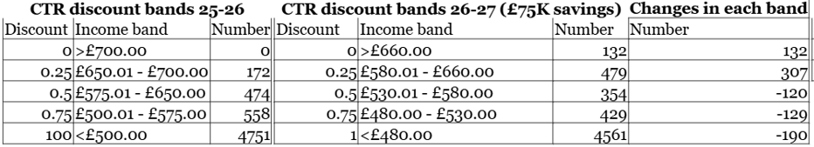

- Reduction in international links post - £50k per annum

Income
- Income over the 4 year period is set to increase by another £8 million, over the current base budget and primarily includes:

- Car parking – £900k increased income– In 2024 car parking revenue was around £1.4 million over the budgeted amount of £8.3 m with particular variances in Worcester Street car park, Opens, Peartree and Redbridge parks and rides. Whilst the recently introduced congestion charge and the awaited traffic filters will have some impact on the income a £900k increase is considered appropriate since the income to date in the current financial year is already tracking £500k over the budget. Overall income will decrease when Oxpens car park closes. In addition there is £128k arising from increased charge proposals.

- Corporate Property - £5.2 million additional income over the 4 year period – The baseline budgeted commercial rent income figure is currently estimated at around £13.5 million per annum for 2025-26. Income for the period 2025-26 to 2028-29 is forecast to increase by £5.2 million with increased income streams from The Store, 6-8 Broad Street, Floyds Row and the full year effect of the redeveloped Odeon. Alongside of this capital receipts will arise from the disposal of South Oxfordshire Science Village (SOSV), Carfax café, HSBC bank and also around £300k of artefacts owned by the City Council which are not currently on display (art, silverware and firearms). The Council could also look to sell the Mayors number plate and there will be a specific question included in the Budget consultation to elicit views on this.

- Advertising - £438k increase by 2029-30. In 2025-26 the council entered into a contract with Clear Channel for a share in the advertising revenue from bus shelters. Now that the contract is more established it is possible to more accurately assess the turnover rent.

- Union Street car park £125k per annum– A feasibility study is ongoing for the alternative use of Union Street car park from 2029-30 onwards

f) Fees and Charges – Details of specific fees and charges increases in 2025-26 are given in Appendix 7 with summary details below:
- Off street Car Parking –
    - City centre goes up by 30p to 50p on all tariffs £5.10 to £6.30 for first hour
    - District centres up by 50p on all tariffs with first hour ranging from £3.10 to £3.20
    - Parks go up by 20p on all tariffs from £1.10 to £1 .60 for first hour
- Park and Ride – Nil on parking only tariffs with first hour free.
- Car parking permits
    - Outer car parks – annual permits up from £105 to £110 alongside other changes
    - Park and rides – annual permit up from £380 to £420 alongside other changes
- Garden waste bins - £94 increased to £98.70 (5.00% increase) with an increase in the concessionary rate from £53 to £55.65 i.e. 5.00%
- Replacement bins – for the replacement of two wheeled blue, green and brown bins - £36.50 increasing to £38.30 i.e. 4.93%% increase
- Bulky Waste collection: Current charge of £23.50 per item increasing to £24.70 (5.11%) and from £34.50 to £36.00 (4.35%) for larger items, e.g. refrigerators, washing machines etc. with concessions remaining unchanged. 50% concessionary rates.
- Land charges – £65.75 to £72.00 - 9.51% increase
- Planning fees – Planning fees were last increased by the Government in December 2023
- General Licenses – Taxi licenses – nil increase. General licenses set by Government with no announcement currently of any increases
- Leisure – increases of between 5-7% reflecting running costs
- Pitch fees: Adult football pitches increased by £2 -£4 for weekdays and weekends respectively and under 17’s £1 -£1.50 for weekdays and weekends respectively.

Other
- Cemeteries- exclusive rights of burial for 50 years- £58 increase per annum (5%)
- Pest Control – rates, mice etc. – 10% or cost of time taken
- Dog warden collection - £179.85 increased by £8.15 (4.5.%) to £188
- Taxi Licenses – Nil increase
- Garages - £1 per week – 5%

Expenditure Pressures

- Excluding pay increases there are other service pressures which are impacting the council the most significant of which include :

- Net cost of Housing Benefits – From 1-4-2025 most working age housing benefit claimants were migrated to universal credit. Whilst most housing benefit expenditure is reimbursed to the authority in full by way of housing subsidy, where supported accommodation is not provided by a registered provider, housing subsidy is capped. In 2025-26 there is currently a pressure of £1 million per annum arising from this expenditure and it is estimated that this pressure will continue to rise to an estimated £3 million per annum from 2026-27. To mitigate this pressure down to £2 million per annum the Housing Team are working to transfer housing stock from non-registered to registered providers.
- Temporary Accommodation (TA) – In 2025-26 the Council made provision for an additional £1.846 million per annum to fund ongoing temporary accommodation costs. Expenditure in this area continues to increase due to increasing demand. Current temporary accommodation placement rates have risen from an average of 4.36 households placed in 2022-23 to 10.2 so far in this financial year and spend is forecast to rise to £3.1 million to £5.7 million by 2027-28. The Council is currently housing 309 households in temporary accommodation but only has around 188 units of its own stock (up from 100 in 2023), albeit there are plans to increase this to 300 units. Taking account of voids around 145 households are in hotel and “B&B” accommodation, mostly single adults. To mitigate this forecast increase in expenditure the following additional measures are being put in place:

  - Acquire 260 new units of temporary accommodation, on top of the current plans for 300 units of which 150 will be delivered via HRA purchases costing around £32million, 60 HRA transfers, 25 conversions from the General Fund and 25 leased. These additions will come on stream over the next 3 years with an estimated 25% to be delivered by the end of 2026/27.
  - Trial implementation of a new Hostel model that would increase support for homeless single adults and bring in an estimated £239k saving per annum
  - An invest to save proposal focused on move on from TA, appointing a commissioned service to focus on the move on of single adults into the private rented sector on a payment by results basis
  - A new face to face offer, allowing us to offer face to face assessments to all homeless applicants, improving our support offer to homeless households and helping ensure accurate priority need decisions which lead to placement
  - Procuring a new ICT systems for Housing Needs to unlock productivity gains for the team

The collective impact on the Housing Service budget is an additional cost in 2026-27 linked to the cost of rolling out measures and new staffing and maintenance costs for a significantly larger TA stock and then savings in 2027-28 of £1.3 million and an additional £146k from 2028-29. The cost avoidance from these measures is forecast to deliver approximately £6m annually by the end of the 4 year MTFP period through the elimination of hotel and B&B use, this is on top of the estimated £8.5 million cost avoidance already being delivered primarily through the 200 units of additional TA currently delivered and other measures. This position can be shown graphically as :

Picture 3 : Temporary Accommodation Increases and mitigations

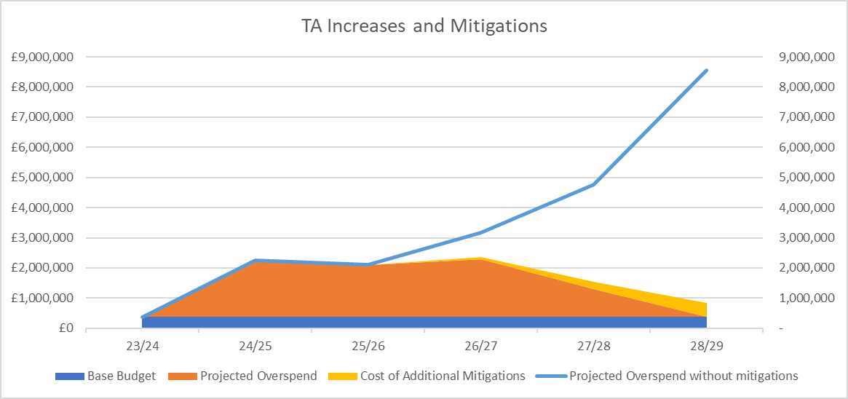

- Oxford Growth Commission - £100k one off staffing support 2029-30
- ICT Inflation - £120k per annum
- Business rates on empty properties e.g. Floyds Row - £188k per annum

New Expenditure

- New Expenditure where the Council has a choice whether or not to undertake is estimated at around £300k per annum. This reflects areas which will be of benefit to the general public who wish to see core council services delivered well. The most significant includes :

- Local Government Reorganisation – Provision has been made for an amount of £2 million in respect of project management resource and consultancy to commence the authorities progress towards local Government re-organisation.

- ODS clienting £160k per annum The council has increased the amount of clienting of ODS in monitoring the way that it carries out statutory services for the council in the following areas
  - £50K per annum in relation to Section 42 and other works within the public highway.
  - Green spaces manager to manage ODS and OCC in areas such as trees, waterway and play equipment.- £70k per annum
  - £40k per annum – administrative assistant reporting to the Client and Commissioning Manager
- Cowley Branch line manger £80k per annum funded from Community Infrastructure levy funding. In October 2025 the government announced £120m of funding to re-open the Cowley Branch line to passengers and create two new stations at Oxford Cowley and Oxford Littlemore in south east oxford. So far £4.4 million has been invested in feasibility work and local partners will be asked to contribute £35 million to the total construction cost.
- Additional legal resource £100k per annum to assist with property transactions
- 2 new officers in the Community Safety Complex case Team £120k per annum to deal with anti-social behaviours and exploitation in the vulnerability housed community, funded from HRA £80K and the Rough Sleepers Homelessness Grant (£40k)
- 3 new Community Response Officers £150k per annum funded by the HRA to provide greater presence and address environmental crime and community safety in our housing areas.
- General licensing team £45k per annum– 1 fte to deal with increased workloads, funded by increased licensing income
- ICT - £1.119 million per annum increased costs arising from
  - Double running of the telephony contract £71k
  - ICT licenses cost uplifts £354k
  - Increased cost of cloud-based technology - £182k
  - Running costs for new Asset Management System - £175k
  - Data storage costs for QL, DRS and Civica in Azure cloud - £300k

- Additional resource in health and safety team - £14k (0.2 fte) per annum
- Increased staffing in events team £50k per annum – this is needed to deliver income anticipated by the MTFS
- Additional data analyst for LGR work from 2027-28 onwards £52k per annum
- Extended opening hours in Hinksey Pool to include March and October - £63k per annum
- Introduction of creche into Blackbird Leys Leisure Centre- £37k per annum
- Broad Street manual cleaning following changes to road layout- £67k per annum
- Weed spraying for garage forecourts and car parks - £15k per annum
- Manual cleaning Woodstock, Banbury, Cowley roads following changes to road and pavement layout-£57k per annum
- Pond cleaning, maintenance of Holywell cemeteries and Port Meadow litter picking - £45k per annum
- Ecologist - £100k per annum. Under the Environment Act 2001 there is a statutory duty to prepare management action plans for our green spaces and to include protection measures for protected species and habitats. There are 1.6fte ecologists in the sustainability team and this will boost their capacity
- Council tax recovery officer - £50k per annum additional resource to assist with the recovery of council tax and business rates debt which has seen an increase of 8,000 properties and £77m debit over the last 15 years with limited increase in staff
- Investigation Services - £40k per annum– funded by increased income - additional officer to secure current income as well as additional income from new contracts
- Data Cleansing Officer- £53k per annum The post will drive and coordinate the implementation of recommendations from the recent (Citizen Contact) Data Cleansing.
- Extended opening hours at Hinksey Pool - £63k per annum to include March and October

- The Council’s General Fund Budget for Consultation is set out in Appendices 1, 2 and 3 attached and summarised below:

Table 5 – Medium Term Financial Strategy 2026-27 – 2029-30

Key:

- MRP – Minimum Revenue Provision – A charge made to revenue in respect of the cost of borrowing to fund the Capital Programme.

Use of Working Balances and Transfers from Reserves

- The MTFP allows for the use of £7.8 million of reserves over the 4 year period. Other earmarked reserves that are not ring fenced at 31-3-2025 stand at around £20 million which could be re-prioritised. In addition to these reserves there is another £3.6 million un-ringfenced working balance.

Risk Implications

- The main risks to the balanced position of the General Fund consultation budget (Appendix 8) are that:

- Provisional Finance Settlement when announced in December is not as good as assumed.
- Savings from efficiencies and transformation are not achieved.
- Council income streams are less than budgeted.
- Failure or uncertainty of major partners to deliver for instance in Leisure.
- Companies do not perform as well as expected leading to reduced income to the Council.
- Business Rates income is lower than forecast.
- Variations in interest rates or non-performance of property funds and multi asset vehicles effecting returns to council.
- Slippage in the capital programme adversely affects revenue savings and additional income in the MTFS.
- Cuts by partner organisations such as the County Council adversely affect service provision.

Wholly Owned Companies and Joint Ventures

Oxford Direct Services Ltd

- On 1st April 2016 the Council established a wholly owned local authority trading company for services provided by Direct Services at that time. The company takes the form of:

- A Teckal company (Oxford Direct Services Ltd)– providing all statutory services to the Council benefiting from a procurement exemption together with externally traded services for engineering, motor transport and building works.
- A Trading Company (Oxford Direct Services Trading Ltd) – providing externally traded commercial waste services.

- The 2024-25 accounts for ODS have now been signed off by the auditors indicating an overall surplus of around £3.11million a £1 million favourable variance to the budgeted position for ODSL and a surplus of £1.1 million, a favourable variance of £0.3 million to budget for ODSTL. A dividend of £2.4 million in line with MTFP expectations was agreed by shareholders on 4th December.

- The last Business Plans presented to shareholders in April 2025 forecast a less than favourable outlook. For ODSL the Plan indicated decreasing profit projections from 2025-26 onwards with 2028-29 surpluses reducing to zero. The company sight increasing unfunded inflationary pressures which are more prevalent in housing repairs. Property services continue to drive the majority of surpluses although this will only defer the decline of overall surpluses. The allocation of more housing related work from the Council to the Company would be one mitigation although it is unclear whether this will occur under more rigorous clienting and commissioning from the Council.

- ODSTL Business Plan fared slightly better, with surpluses forecast to rise from £623k in 2025-26 to an estimated £2.5 million in 2028-29 driven by organic, aspirational growth, particularly in commercial waste, property services, facilities management and acquisitions.

- At shareholders on 4th December a revised business plan was presented to shareholders for the 2 companies. For ODSTL the growth of surpluses is less aggressive than previously shown with surpluses of £2.5 million topping out in 2029-30 rather than 2028-29 shown previously. ODSL surplus indicates more optimism, arising from increased payments from the council, a reduction in overheads by the Company, as well as potential increased volume of work from the Council. Whilst the surpluses continue to decline the indications are that they will stay above breakeven over the next 4 year MTFP period.

- The decline of surpluses in ODSL is shown below as being replaced by surpluses in ODSTL and hence the overall dividend to the council should remain stable especially as the company also has access to other retained profit. A prudent amount of dividend of around £2.4 million per annum has been estimated over the 4 year period of the MTFP i.e. a reduction of around £2.4 million over the 4 year period to that previously forecast.

Table 6 Oxford Direct Services Surpluses and Estimated Dividend

Note : The dividend is paid to the council in the year after the year to which it relates

Housing Company- Oxford City Housing Ltd trading as OX Place
- March 2016 the Council approved the establishment of a wholly owned Local Authority housing company that was incorporated in June 2016, Oxford City Housing Limited with the objective of delivering affordable housing and also a financial return back to the council. The Company, consisting of a holding company OCHL (Holding) Ltd, a development company, OCHL (Development) Ltd and an investment company OCHL (Investment) Ltd trades as OX Place.

- In November 2024 shareholders agreed to the transfer of properties from the Barton development that were managed by OCH(I)L to be transferred to the Councils HRA. This decision was ratified at Council on 25th November 2024 together with a decision for all future properties from the Barton development to be purchased by the Council. The company will become a dormant legal entity pending a decision on its future use.

- The 2024-25 audited accounts were presented to shareholders in November 2025 with a recommendation for a dividend payment to the shareholder of £4.463 million following the payment of £5 million of dividends in the previous 2 years.

- The Company are also intending to pay a dividend of £3 million in 2026-27 which has been factored into the MTFS. After this, there are no currently no further dividends forecast by the Company or included within the councils MTFS. At shareholders in December shareholders were advised that following changes to tenure and the delivery of a number of key schemes such as Redbridge and Sandy Lane, there would be a significant increase in forecast surpluses, although it was too early to include these surpluses in any dividend recommendation, given the need for these schemes to obtain planning permission. The Company are currently considering their business strategy going forward which will be presented to shareholders in due course.

Oxford West End Development (OXWED LLP)

- The Council has a 50/50 partnership with Nuffield College to undertake the development of the land at Oxpens for residential and commercial purposes. The 2024-25 accounts for the LLP have recently been approved and indicate a loss for the organization of £2.6m for the year.

- The Council has invested money on a 50/50 basis with its partner Nuffield College at a loan investment rate of 4% above base rates with loans outstanding and accrued interest at 31-3-2025 of circa £21 million.

- In October 2025 the scheme received planning permission, and an update will be presented to shareholders in December.

- The overall aim of the development was that there would be significant gross value added, additional council tax, business rates and dividend return from the LLP. However, shareholders were advised that the market for this type of development had changed and the scheme would require a different delivery strategy. This strategy was being worked up and would be the subject of a report to the next meeting of shareholders. It is unlikely that this strategy would lead to any financial return to the Council over the next 4 year MTFS.

Section C Housing Revenue Account Budget

Background

The Council continues to operate an ambitious programme of investment both in the maintenance and refurbishment of its existing stock of 8,077 council dwellings, regeneration of its council estates and investment in new social housing dwellings constructed by the Council’s wholly owned company Oxford City Housing Limited (OCHL). The current HRA Capital programme includes £165 million being spent on the purchase of 448 new build affordable homes from OCHL. The overall commitment to OCHL is for the purchase of 806 dwellings will be completed over the MTFP (running to March 2030), of which 424 will have been completed by 31st March 2026.

In addition to the OCHL new build developments, the HRA is directly commissioning 847 affordable homes with an overall budget of £286 million. 107 of these homes are forecast be completed by 31st March 2026.

There will also be 117 acquisitions in the same period. This includes the RRTBR programme, delivery through grant funded acquisition programmes and the additional acquisitions programme approved by Cabinet in April 2024. Further to this there is a strong pipeline of potential incoming schemes.

- In managing the future risks that will inevitably start to rise as more debt is taken on to facilitate new build housing and regeneration the Head of Financial Services as well as paying attention to net income makes use of Prudential indicators to manage these risks. Prudential indicators are used in the Treasury Management Strategy and are a matter of judgement by the Section 151 Officers but those typically used by banks and building societies to assist management would be:

- Interest cover ratio – ratio of operating surplus divided by interest cost i.e. how many times interest can be paid from surpluses.
- Loan to value ratio- outstanding debt/ fixed asset value at year end.
- Debt to income ratio – Turnover / debt

- The most widely used ratio is interest cover and used by the Council which measures how many times surpluses cover the interest charge and typically Registered Providers would operate on a ratio of 1.72:1 and 2.1:1. As a golden rule 1.25:1 would be acceptable especially given the significant housing development being undertaken by the Council.

- Due to the increased demands placed on the HRA through the new compliance regulations (as introduced by the Regulator for Social Housing) the Section 151 Officer has agreed a trajectory of interest cover ratio of 1.10 : 1 over the first 4 years of the Business Plan and thereafter budgeted spend is approved which seeks to ensure that this ratio is maintained at a level of at least 1.25:1.

- The chart below shows this ratio graphically.

Picture 4 : Impact on Interest Cover Ratio
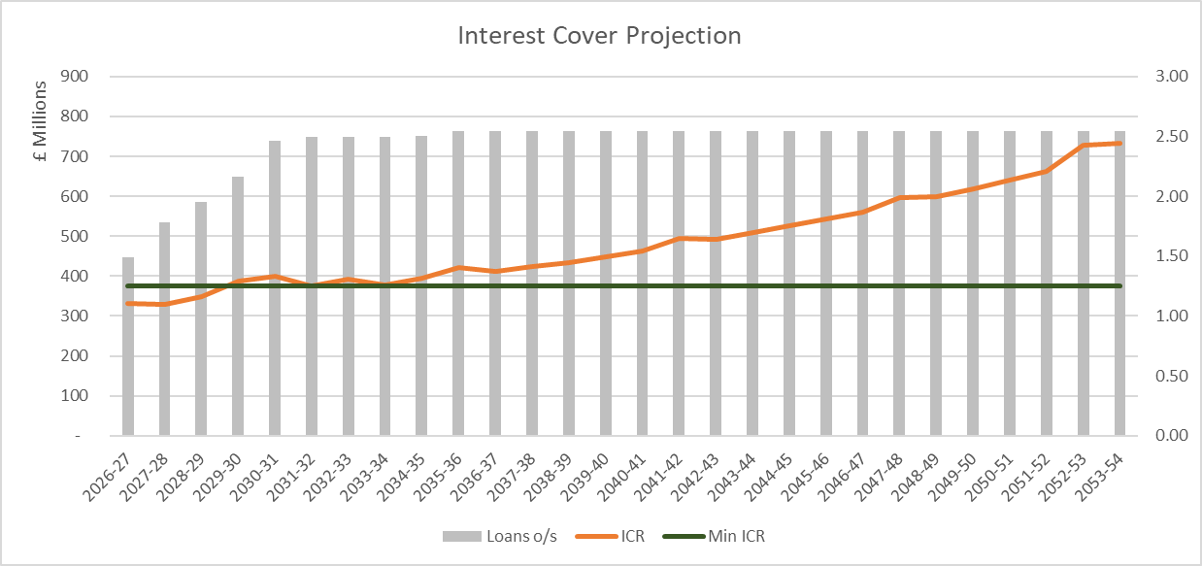

Table 7 : Increase Cover Ratio
Interest Cover Projection | 2026-27 | 2027-28 | 2028-29 | 2029-30 | 2030-31 | 2031-32 | 2032-33
ICR | 1.10 | 1.10 | 1.16 | 1.29 | 1.33 | 1.25 | 1.31
Min ICR | 1.25 | 1.25 | 1.25 | 1.25 | 1.25 | 1.25 | 1.25

In line with the assumptions below the above chart indicates

- The HRA programme is borderline affordable with the ICR marginally below the minimum of 1.25 until 2029-30. There is in effect no capacity for further spend in the HRA Business Plan in the medium term.
- The rent increases have been extended at CPI+1% for a period of 10 years post 2025-26 resulting in further borrowing capacity from around 2032-33 of around £800m over the next 30 years. Although not included over the next 5 years, the council will have choices of where to spend the additional borrowing capacity that is expected to arise from 2032 onwards. Although not exhaustive these choices would include:
- Existing dwellings – additional investment for decent homes standard which is not currently in the programme.
- Zero carbon works – Included within the 5-year Investment Plan is £22 million for energy efficiency works which will assist with progressing the council towards zero carbon by 2040. Notwithstanding the potential additional borrowing capacity, the current HRA business plan already includes a total of £48 million for the 40-year period.
- New dwellings –the current 10-year housing investment programme with OX Place, notwithstanding slippage, will come to an end in 2032. There is potential to extend the housing investment programme to create more social housing in Oxford.

Key Assumptions in the HRA Business Plan

- The rent increases included in the HRA Business Plan are based on CPI+1% for the next 10 years.
- An announcement regarding the proposals for rent convergence is due at the end of November The re-introduction of rent-convergence measures as per the Government’s consultation document “How to implement Social Rent convergence” published on 2nd July 2025, would affect the following number of tenants and give rise to increased rental income for the HRA as follows:
Table 8 : Impact of rental convergence
Proposed Weekly Convergence Rate | Number of affected Tenants | Weekly Additional Rental Income | Annual Additional Rental Income
£1 | 6,884 | £6.875.04 | £357,502.08
£2 | 6,884 | £13,745.08 | £714,744.16

- The HRA BP assumes that it will continue to purchase the affordable housing from OCHL’s 8-year development programme 1,200 properties within a gross overall budget envelope for all years of £452m before grant and shared ownership sales. The HRA purchases such social dwellings from OCHL based on a set of ‘financial viability indicators agreed with the Councils Section 151 Officer as follows:

- Net present value (NPV)– positive over a 70 year period
- Payback – 70 years or under
- Internal rate of return IRR -(the discount rate which equates the Net Present Value to zero) of 3%

- These criteria are comparable to the Housing Company of a positive NPV over 40 years, 40-year payback and 4% IRR. The HRA criteria are less favourable to reflect the nature of the social dwellings being purchased.

- The debt profile of the HRA together with the resulting HRA working balance over the next few years is shown as follows:

Table 9 : HRA Outstanding loans and Working Balances
 | Closing Loan Balance | Working Balance
 | £000’s | £000’s
2026/27 | 449,079 | 4,278
2027/28 | 537,079 | 5,501
2028/29 | 589,079 | 7,579
2029/30 | 651,079 | 11,930
2030/31 | 742,079 | 17,366
2031/32 | 752,079 | 11,279
2036/37 – Peak Debt | 767,079 | 52,444
2063/64 | 75,551 | 340,259

- In the latter years of the 40-year Business Plan, HRA working balances begin to increase once again, enabling increased activity to be undertaken.

Key assumptions made in preparing the HRA budget for 2026/27 – 2030/31

Rent Increases

- The Regulator is expected to publish the final Rent Standard following the Autumn Statement on 26 November 2025, which will confirm convergence mechanisms and uplift limits. It is worth noting:
- The new policy will apply for at least 10 years from April 2026.
- It covers low-cost rental accommodation (not shared ownership).
- It reintroduces rent convergence for properties below formula rent.

- The maximum increase in rent for the period 2026/27 to 2035/36 is expected to be restricted to CPI (as at September of the previous year) plus 1 percentage point + up to [£1/£2] in any year where actual weekly rents are below formula rent. If the difference between actual weekly rents and formula rent is less than [£1/£2], then the level of uplift will be adjusted accordingly so that the weekly rents charged do not then exceed formula rent.

- As well as the restriction on maximum increases, rents are also capped as follows:
- Social Rent – applies to the majority of council dwellings - rent caps apply as a maximum ceiling on the formula rent and depend on the size of the property (the number of bedrooms it contains). Where the formula rent would be higher than the rent cap for a particular size of property, the rent cap must be used instead.
- Affordable Rents – applies to around 68 of our dwellings - The rent for affordable rent housing (inclusive of service charges) must not exceed 80% of gross market rent. ‘Gross market rent’ means the rent (inclusive of any applicable service charges) for which the accommodation might reasonably be expected to be let in the private rented sector. Property size, location type and service provision must be taken into account when determining what gross market rent a property might achieve if let in the private rented sector.

- The HRA must adhere to these restrictions and caps on rent increases even if a tenant’s rent is below formula rent, or if the HRA has previously applied a lower – or no – annual increase. Where this is the case, the HRA may only move the rent up to formula rent when the property is re-let following vacancy (subject to the rent cap).

- The table below demonstrates the amount of rental income foregone as a result of these restrictions.

Table 10 : Rental Income Foregone
 | Number of Properties | Total Weekly Rent Foregone | Total Annual Rental Income Foregone
Actual Rent is less than Formula Rent | 7,986 | £77,385 | £4,024,020

Rent Flexibility

- Landlords are permitted under the regulations to set rents at levels above the social formula rents where it has taken local factors, market conditions and affordability into account. For general needs accommodation a 5% flexibility is allowable which the Council already applies to new build housing. For supported housing, such as sheltered schemes a 10% flexibility is allowable.

- Not all our rents are at a level equal to the formula rent for the property. Where a property becomes vacant and is going to be let to a new tenant, the formula rent for the property shall be set at 105% of formula for general needs accommodation and 110% of formula for all supported housing units.

- For planning purposes, the assumed rent increase for 2026-27 is assumed to be 4.8% with increases of 3% assumed for future years. The impact on current rents of this increase together with an allowance of £2 per week for movement towards formula rent results in an average increase of £8.47 per week, details of which is shown in Appendix 5.

Shared Ownership Dwellings

- The rent increase for Shared Ownership will be CPI + 1% based on the CPI rate for the 12 months to the end of September 2025. This will only apply for shared ownership properties owned for the whole of the preceding 12 months (i.e. before 1st October 2024). For properties purchased after the 1st October 2024 the increase for 2026/27 will be 0.5%.

- The rent rise included in the Consultation Budget under these agreements is effectively an increase of 0.5% for properties less than 12 months old (as at 30th September 2025) of which the council currently has 4 such properties and CPI + 1% (4.8%) for older properties of which the council has 64 properties

Right to Buy and other disposals

- Disposal of around 20 dwellings per year is assumed from 2026-27 onwards although this may be optimistic given the recent reduction to the discount rates. Within the development programmes to be purchased from OX Place, there will be shared ownerships on most of the schemes. The Council will receive a capital receipt from the initial element purchased by the homeowner. There will also be additional capital receipts if the homeowners opt to make additional investment in the share of their home known as ‘stair-casing’ enabling the homeowner to own a greater proportion of their home.

- Local authorities are now able to retain 100% of capital receipts, although the maximum discounts on Right-To-Buy housing applications has been reduced. The decrease in the discount may well see the number of property disposals reducing which may counteract the additional freedom to retain 100% of the receipt.

Inflation and pay assumptions

- All the assumptions for inflation are the same as for the Council’s General Fund.

Service Charges
- Service charges are currently being reviewed, and where possible the service charges will be based on the actual costs incurred by the Council.

- For service charges where the actual breakdown of costs is incalculable, they will be increased by CPI +1% i.e. 4.8% in line with the rental charge across all tenure types in the HRA. This increase will ensure that the income will cover the actual costs that have increased by RPI.

- There is no proposed increase to the Furnished Tenancy multiplier in respect of charges to tenants who take up the offer of the provision of white goods and other fittings. The current multiplier of 1.5155 is considered sufficient to cover the costs of running the scheme.

Working Balance
- The working balance levels allow sufficient monies for the funding of future years’ Capital Programme, the repayment of the debt, as well as an amount of £3.5 million as being the minimum required to cover unexpected events such as falling investment income or increased costs.
Variations to Budget

- Variations to the HRA budget are shown in Appendix 3 with explanations shown below:

Service Pressures

- Shared Ownership Repairs Allowance (£5,000)
- Complaint Compensation (£30,000)
- Council Tax for Long-Term Void Properties (£180,000)
- Service Charges (£40,000)
- Increase in ODS Caretaking & Estate Services (£318,000)
New Bids
- Increase in resident Involvement budget to reflect the reset work - Resident Rewards, training, conferences & events (£40,000)
- Increase in Elmore complex case capacity (£30,000), to ensure that there is sufficient complex needs support of tenants beyond the tenancy sustainment offer
- 3 x Community Response Team Officers (£150,000)
- Localz Contract funding for ODS (inc. text message bundle) (£40,000)
- Consultants for QL Project x2 (£200,000)
- Provision for HRA Asset Management Team (Gross increase of £2.2 million or £1.588 million after recharges to capital)
- Additional staffing and repair and maintenance costs for additional TA units (£200,000)
Revenue Budget Savings / Reductions:
- Efficiency Savings following budget review (£200,000)
- Increase in Costs recovered through Housing Benefit by remodelling our approach to Temporary Accommodation (£363,000)
- Shrubs ICT system (£40,000)
- TA Rental Income for 150 new Units @ £120 per week (£936,000)
- Gap Funding from Housing Needs for TA Units (£360,000)
Capital budget amendments:
- Acquisition of 150 TA Units at a total cost of £32m (Saving the GF financing costs of circa £1.7m per annum)
- Re-procurement of Housing & Asset Management System inc. mobile £2m (This is required to commence procurement and may not be needed in full.
- Inclusion of an additional £12m contingency for Tower Block Remediation Works.
- Tower Block Water tanks £100k feasibility
- Play / Seating Areas £60k per annum
- Contingency for in-year additional demands or regulatory changes £0.5m
- Contingency in the capital programme for urgent additional works identified through the remaining stock condition surveys now underway (17% of the stock). £0.5m
- 3x new direct delivery development schemes have also been included (Elsfield Hall, Knights Court, and Cave Street), the budget for which is currently included in the budget for purchases from OCHL.

Housing Revenue Account Budget 2026/27 to 2030/31

- Appendix 4 details the HRA Budget for the period 2026/27 to 2030/31 which is summarised below:

Table 11 – Housing Revenue Account (HRA) 2026-27 to 2030-31

 | 2026/27  £000’s | 2027/28  £000’s | 2028/29  £000’s | 2029/30  £000’s | 2030/31  £000’s
Income | (68,207) | (74,958) | (78,766) | (84,390) | (89,017)
Expenditure | 66,639 | 73,766 | 76,729 | 80,098 | 83,665
Net Operating Expenditure/(income) | (1,568) | (1,191) | (2,037) | (4,293) | (5,352)
Investment income | (43) | (32) | (41) | (58) | (84)
(Surplus)/Deficit for the Year | (1,611) | (1,223) | (2,078) | (4,350) | (5,437)
(Surplus)/Deficit b/fwd | (5,832) | (7,443) | (8,666) | (10,744) | (15,094)
(Surplus)/Deficit c/fwd | (7,443) | (8,666) | (10,744) | (15,094) | (20,531)

Risk Implications

- The main risks to the balanced position of the HRA are summarised below and detailed in Appendix 8:

- The government introduces a rent cap which is less than CPI+1%
      - Increased arrears due to benefit changes
      - Construction delays in Housing Company and subsequent effect on capital spend on new housing and net rental streams.
      - Variations in estimates causing cash flow problems.

Section D Capital Programme

Optimism Bias

- In previous years the spend profile on the programme has not matched that of the budget set. Typically, only spend of around 60% has been achieved. This shortfall can be for a number of reasons, most simply relating to delays in development, not least due to cost and borrowing increases, and the complexity of some of our key sites and assets, most of which members will be aware of. This underspend can have a significant impact on the local authorities' finances. On the one hand, not spending money reduces the need to borrow, but failing to spend money planned also reduces the ability to plan available funds and can reduce investment income.

- The HM Treasury Green Book on how to appraise programme and projects also recognises ‘optimism bias’ or the tendency for appraisers to be over optimistic about key project parameters including capital costs, operating costs, and project duration. The Green Book recommends adjusting for this based on past experience.
- In drawing up the capital programme for this year an optimism bias has been applied to both General Fund and HRA Capital which has the effect of reducing the capital with cost of capital revenue costs being adjustment accordingly in the MTFP.
- The total budgeted capital spend of £725 million over the four year programme is therefore reduced to £696 million, as follows:

Table 12 : Capital Programme Optimism Bias

General Fund Programme

- The total programme over the four-year period is estimated at £146 million. Applying optimism bias of 40% taking into account slippage from 2025-26 increases the programme to £168 m.

- New ICT Schemes of around £2.7 million are included in the budget as well as £1 million for Oxford ice rink roof works, £317k of street light upgrades and £260k for electric vehicle charging infrastructure for fleet. Additionally works added from the capital pipeline includes £1million for waterways investment, £150k for fire risk assessments, £100k for stone wall refurbs. £750k for Blackbird Leys regeneration, £200k for a new substation at the covered market, £600k for replacement lifts.

Pipeline of capital projects

- There are a number of capital projects totalling £42.7 million which have yet to be fully worked up such as energy surveys, town hall works and waterways. These are held in a pipeline which will be subject to the full rigour of scrutiny through the Development Board before being submitted for member approval. These schemes include :
- Oxford flood alleviation- £1.3million. The Council has previously contributed towards this scheme (£1.5 million plus £900k of land). The Environment Agency are looking for further funding although if approved this will be the back of the MTFP
- Cowley Branch Line £32.5 million – Additional to existing capital scheme to be funded by partner contributions for which the council will be the accountable body
- Waterways capital investment £3m - to make sure that waterways ownership is safe, following survey work to sluice gates, banks, tow paths, culverts etc
- Town Hall property works – extension to the town hall works programme - £4m
- Hinksey Pool Sauna - £79k is included as an indication of the potential cost but a firm proposal needs to be worked up.

- Funding of the Program is by Community Infrastructure Levy and Section 106 £8 million (5%), borrowing £100 million (68%) Government Grants £11 million (8%), capital receipts £27m (19%) All revenue costs have been included in the General Fund revenue budget.

Housing Revenue Account Capital Program

- The draft HRA Capital Program is intrinsically linked to the HRA Business Plan since the resources to fund the Programme are largely generated through housing rents. Appendix 6 shows the existing HRA capital program over the next four years totaling £578 million before the application of optimism bias which reduces the programme to £527million.

- The draft HRA Capital Program can, for the most part, be categorized as follows:
  - Investment in existing housing stock – Planned Maintenance
  - Social Housing Acquisition and Development Program – new homes. In total this is shown as £390 million over the 4-year period 2026/27 to 2029/30 with around £180 million being delivered by Oxplace and £210 million via direct delivery through the HRA. Specific details of schemes being delivered by Oxplace are shown in the exempt from publication Appendix 10

- The 5-year investment program plan for our existing housing stock has been developed on the basis of the latest stock condition surveys (over 85% of council homes had been surveyed, the remaining 1140 homes had no access as at the end of September 2025 and these remaining surveys will be undertaken by an external contractor by the end of March 2026). In addition to the stock condition reports, the new Housing Regulation and Inspection regime; the new Client Management arrangements; and Revised Financial Arrangements were also considered.

- The new investment plan consists of the following components, all of which contain further detailed breakdowns of projected costs:
  - Safety & Compliance Works
  - Works to Street Properties
  - Works to Blocks & Flats
  - Other Priority Spend Areas
  - Works to Energy Efficiency Targets
  - Capital Projects

- The Social Housing Acquisition and Development Program has been amended to reflect the latest profiled forecasts. Some schemes have also been moved to direct delivery by the HRA but are still being overseen by the OXP team. Reprofiling is required as some schemes face many challenges during the development phase which can cause significant delays – planning objections and policy changes, and procurement and contractor issues.

- The financing of the HRA Capital Programme is from capital receipts £48 million, (8%) arranged borrowing £449 million (78%), Major Repairs Reserve £54 million (9%) and Homes England Grants £28 million (5%)

Risk Implications impacting the Capital Programme

- The main risks to the Capital Programme are set out in Appendix 8 and summarised below:

- Right to buy disposals as detailed in the assumptions are not as forecast causing a shortfall in funding of schemes.
- Delays in construction of new homes by OXPlace.
- Slippage in Capital Programme and impact on delivery of priorities.
- Robustness of estimates.

Budget next steps

- The timetable for consultation and for Budget approval by Council is set out in the following table:

Table 13: Budget Consultation Timetable
Consultation Budget Report to Cabinet | 10th December 2025
Budget Consultation Period | 11th December to  31st January 2026
Final Budget Report to Cabinet including outcome of Consultation | 11th February 2026
Budget approval and Council Tax Setting Council | 23rd February 2026

- The Council will make use of its citizens’ panel as well as an online survey. The survey will be publicised in local newspapers and the budget will be shared with other stakeholders, such as trade unions and local voluntary organisations and businesses for comment.

- Tenants will be consulted on the HRA budget including rent and service charge changes with a special resident focus group(s) and the tenant newsletter 'Tenants in Touch'.

Financial Implications
- These are covered within the main body of the report.

Legal Implications

- Section 30 of the Local Government Finance Act 1992 requires that a local authority ‘must set a balanced budget and council tax before the 11th March in the financial year preceding that for which it is set’. Consultation will be undertaken with the General Public for a period of six weeks in accordance with CIPFA Guidance.

- The Local Government Act 2000 in particular Section 9 states that it is the responsibility of the full council, on the recommendation of the Cabinet to approve the budget and related council tax demand.

- The Local Government Act 2003, section 25 requires the Council’s Section151 Officer to report to the council on the robustness of the estimates made and the adequacy of the proposed financial reserves assumed in the budget calculations. This will be done at Council in February 2025 when the Budget is approved.

- Failure to set a legal budget may lead to intervention from the Secretary of State under section 15 of the Local Government Act 1999.

Risk Implications

- Detailed risks are shown in Appendix 8 of the report.

Equalities Impact Assessment
- These are shown in Appendix 9 of the report.

Name and contact details of author: -
Name : Nigel Kennedy
Job title : Group Finance Director (Section 151 Officer)
Service Area / Department : Financial Services
Tel: 01865 252708 e-mail: nkennedy@oxford.gov.uk

